1] successfully created the VPC

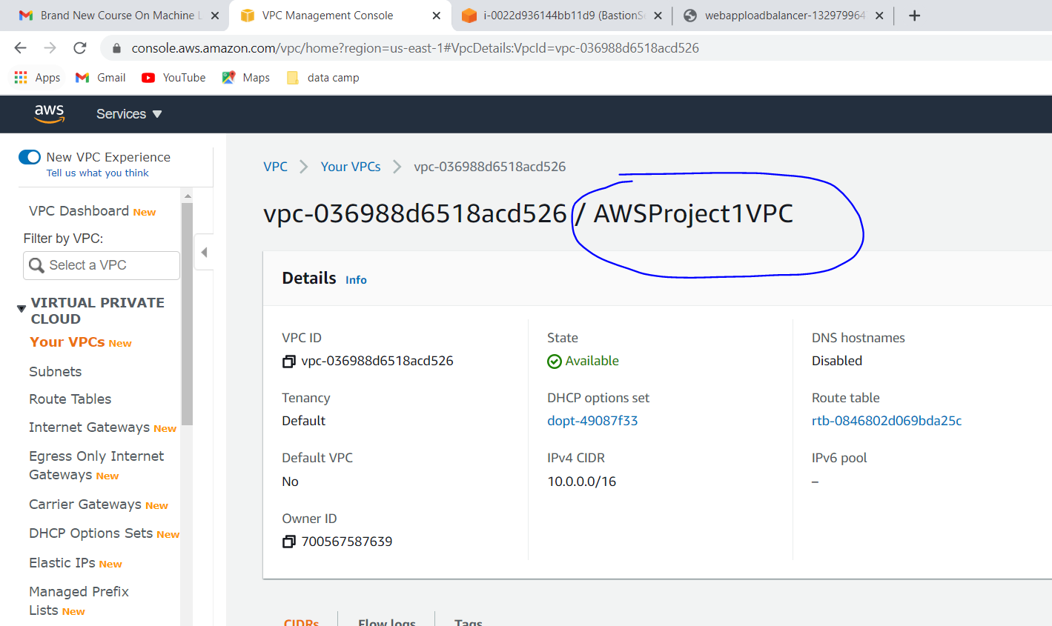

2]successfully created the pubic subnet and private subnet and 3 publicsubnets for multiple AZ

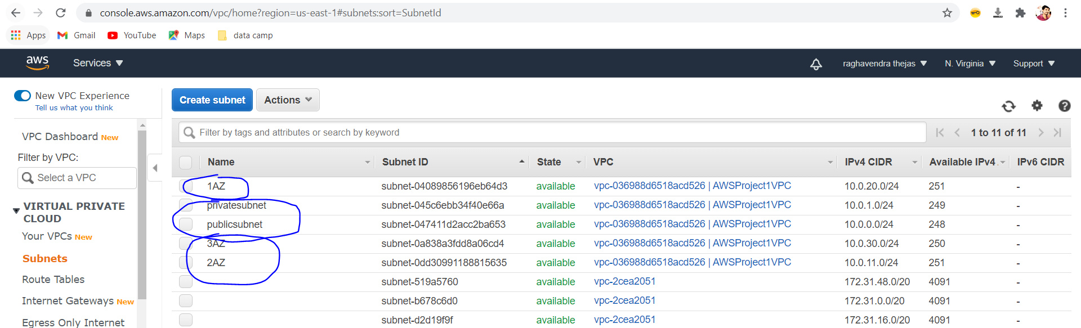

3]Successfully cretead the IGW and attached VPC

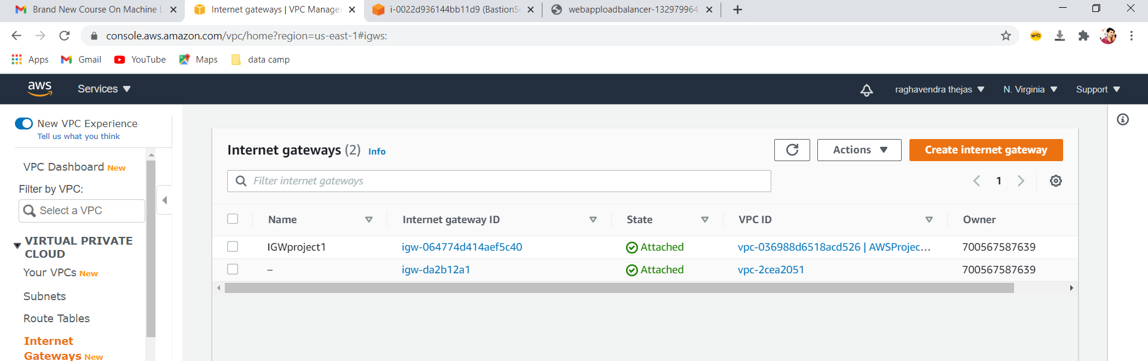

Next page

4]successfully created the route tables

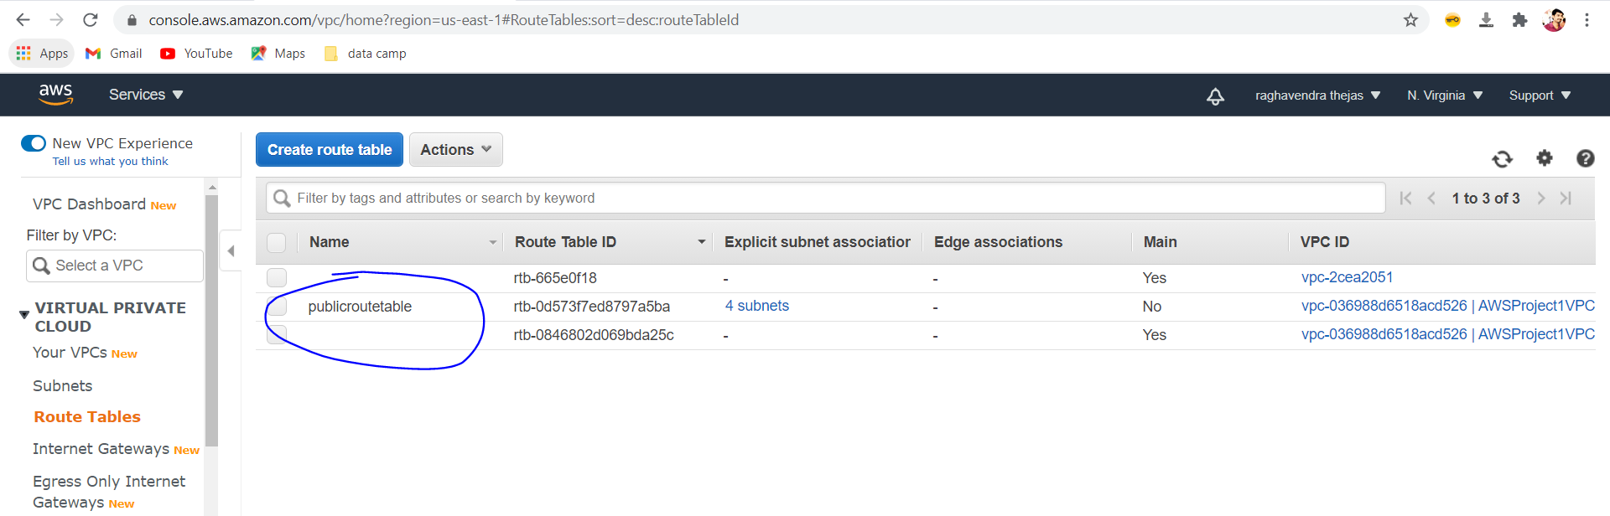

5]successfully created the NAT gateway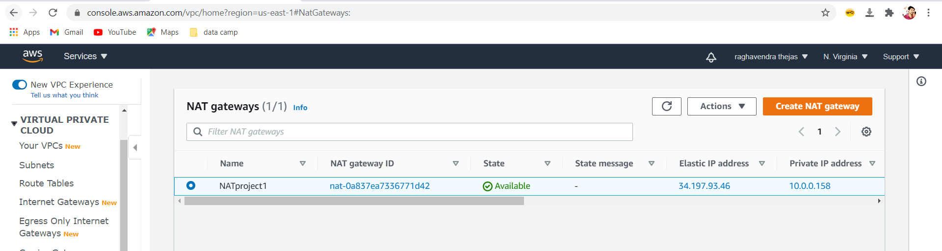

6] Successfully created the Bastion Server

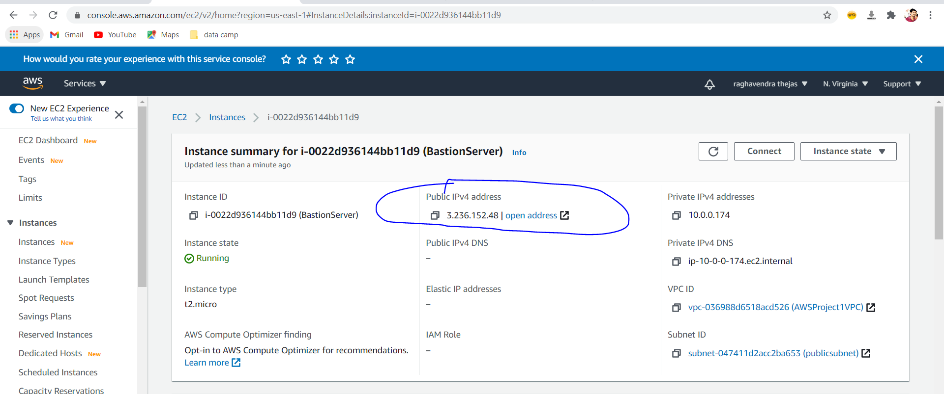

Next page

7]successfully created the Loadbalancer SG,webserver SG and Bastion SG

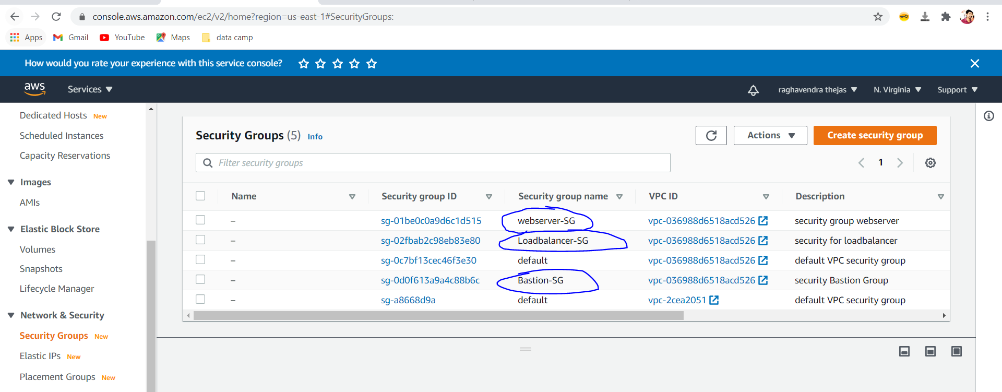

8] successfully created the webserver1,webserver2

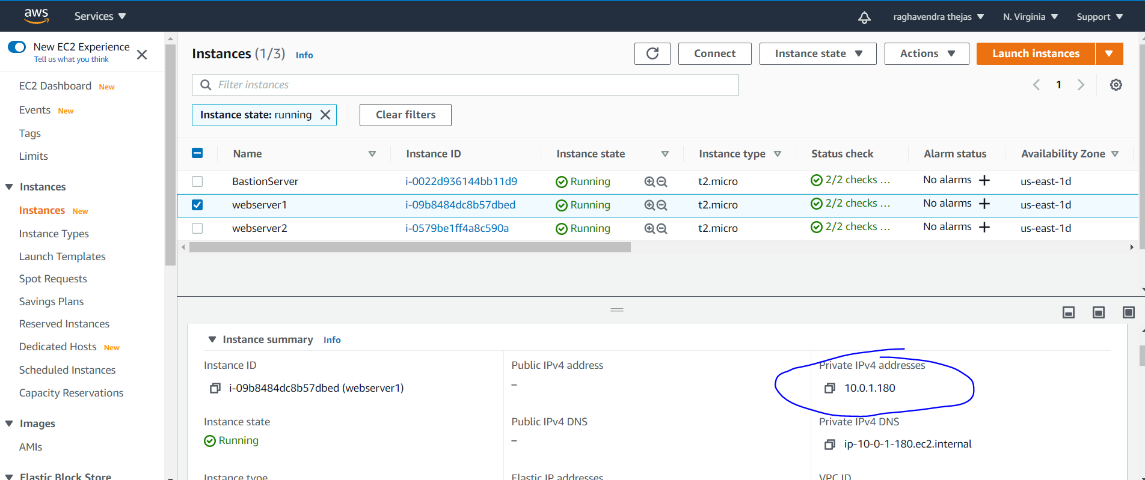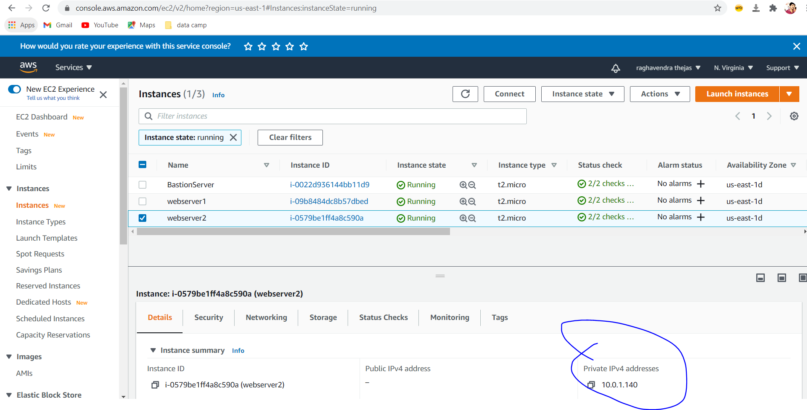

Next page

9] successfully created the load balancer

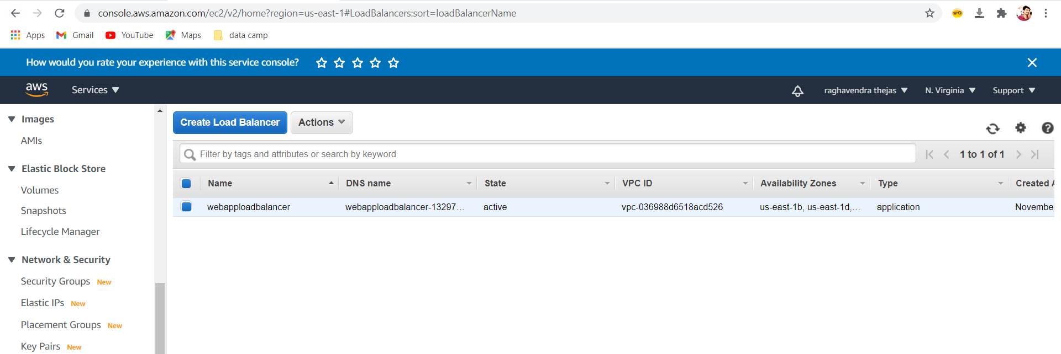

10] Successfully able to login to bastion server and connected to webserver1

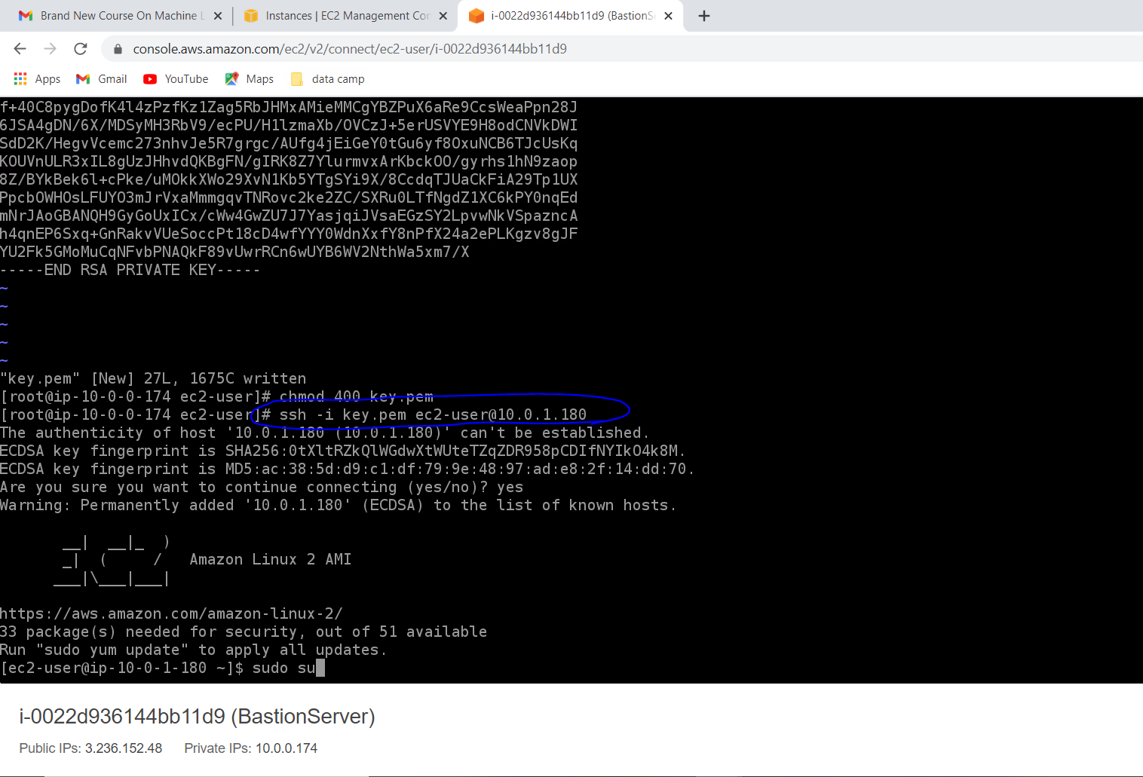

Ran all commands in webserver1 through bastion server

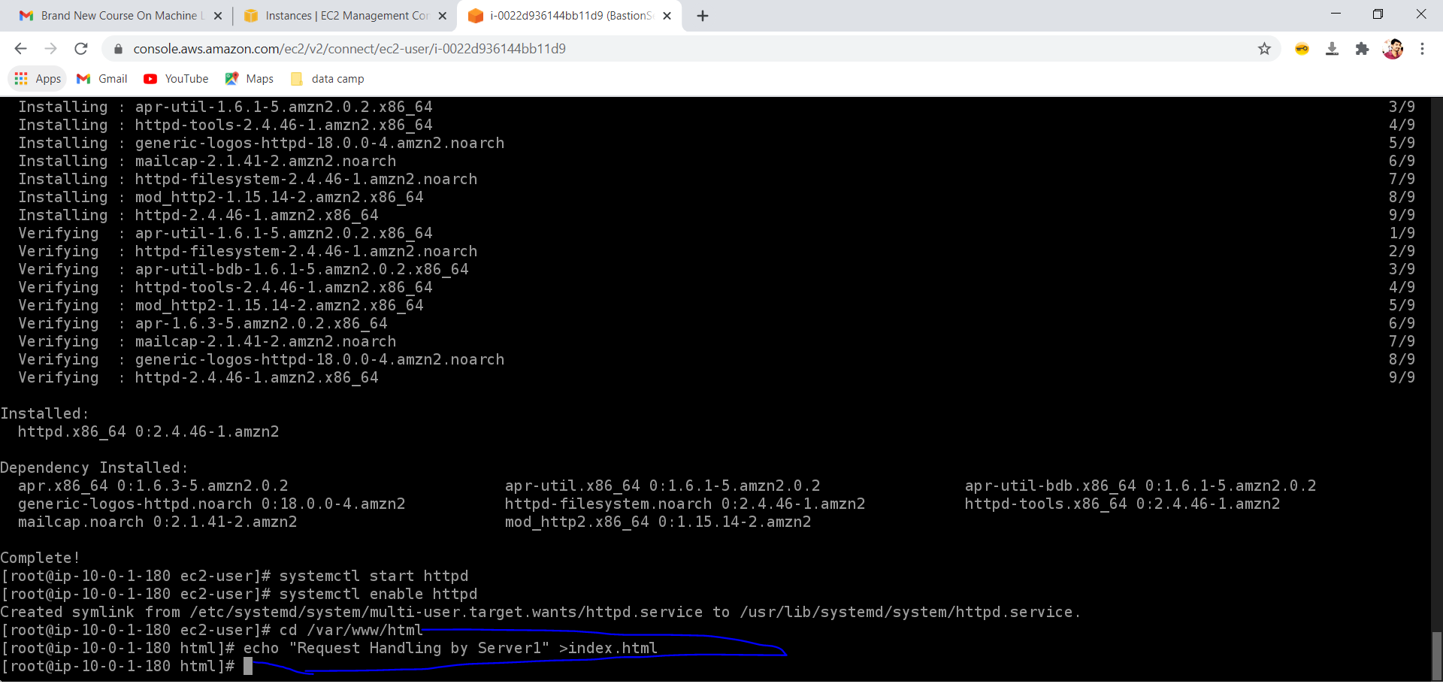

Next page

11] Successfully able to login to bastion server and connected to webserver1

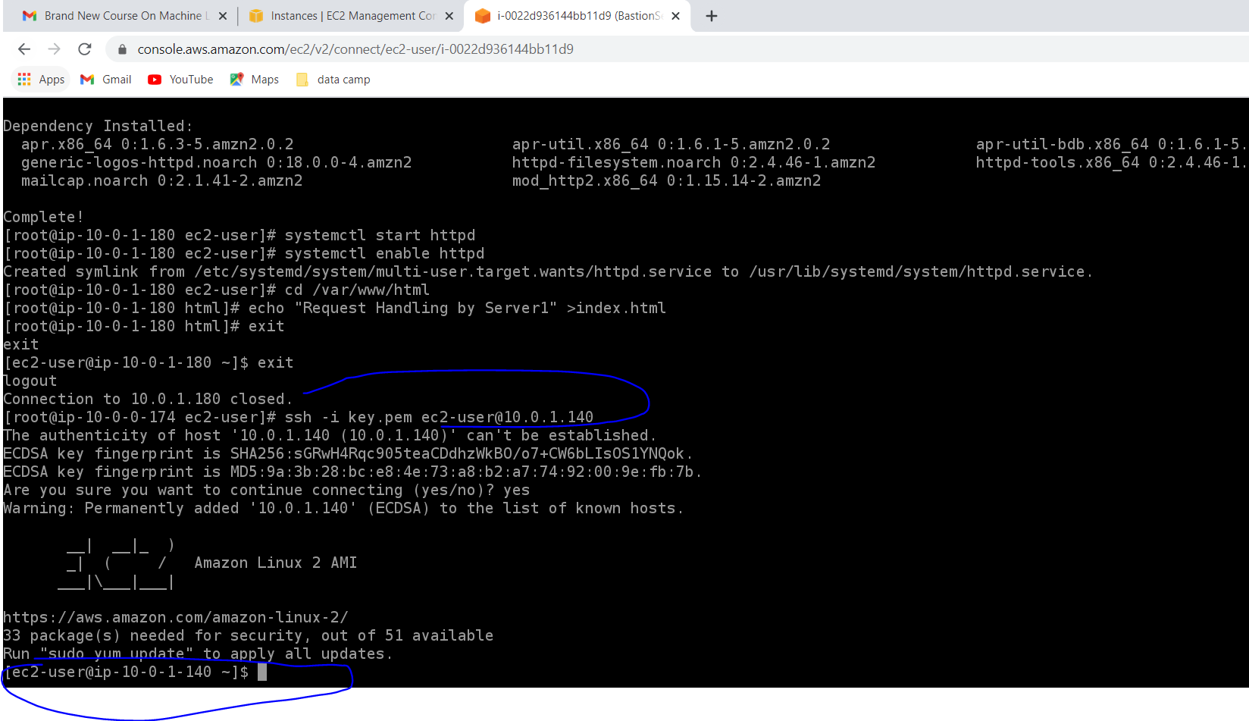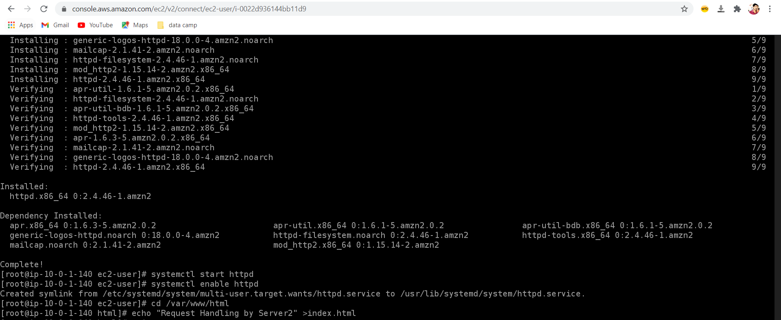

12] Came out from both servers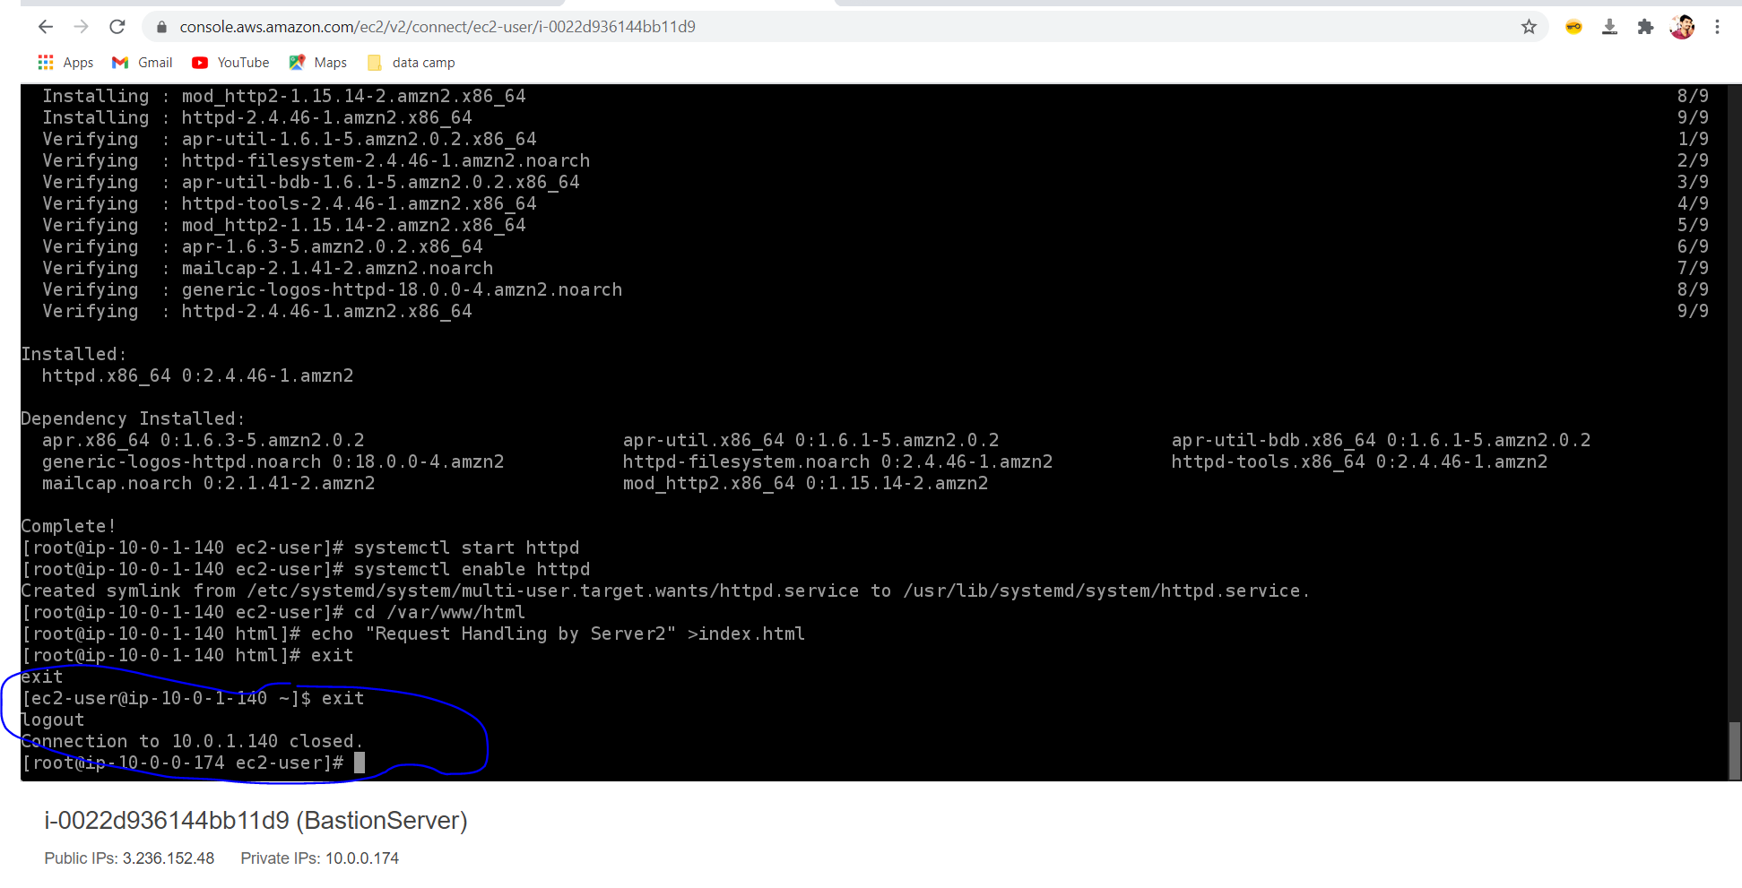

Next page

13] Load balancer URL working perfectly using both webservers

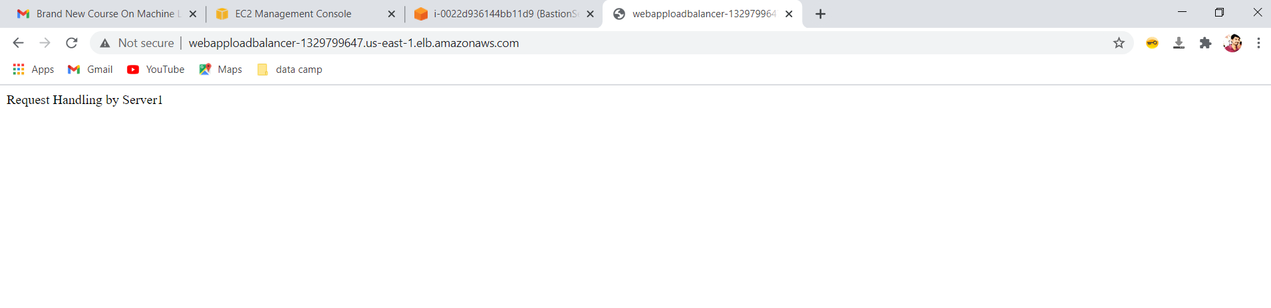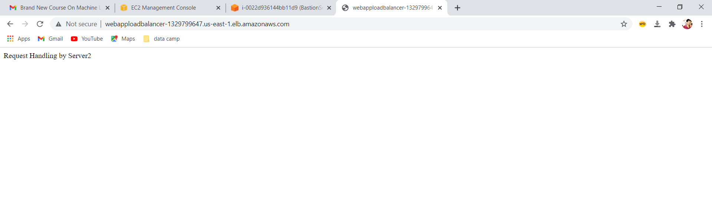

End of project1